Introduction
Wythe-Bland Foundation was formerly known as “Wythe County Community Hospital Foundation” (WCCH Foundation) and originally formed in 1991 to support the charitable needs of Wythe County Community Hospital. On May 31, 2005, the Hospital leased its buildings and related real property and sold substantially all of its other assets to a subsidiary of LifePoint Hospitals, Inc. The proceeds from the pre-paid lease, asset sale, and existing WCCH Foundation funds were transferred to establish the new foundation. This pre-paid lease created the charitable wealth that generates earnings from investments to provide grant resources to Wythe and Bland County eligible not-for-profit organizations. The foundation was re-organized on June 1, 2005 and is no longer affiliated with the Hospital. It is recognized as a Conversion Foundation, sometimes referred to as a Health Legacy Foundation. In 2010 the foundation changed its name and nonprofit status from Wythe Bland Community Foundation to Wythe- Bland Foundation. This change was a result of the IRS determination that the organization is a Private Foundation since its primary form of revenue is derived from investment income. Grants are awarded each year to qualified applicants that provide benefits and essential services that improve health, education and welfare, with an emphasis on health, to the citizens of Wythe and Bland Counties. The Spending Policies and Community Investment Strategies of the foundation have been created to preserve the asset base as an enduring endowment. The spending for grants and management of the foundation are limited to approximately 5% of the value of the asset base annually.

The Wythe-Bland Foundation is a Virginia non-stock, non-operating foundation exempt from income taxation under Section 501(C) (3) of the Internal Revenue Code. It is managed by a board of 13 members who are community leaders residing in Wythe and Bland Counties, Virginia. Board members serve without compensation.

Since 2005, the foundation has provided approximately $40,313,182 with another $425,000 expected to be expended this year for the Wytheville Community College Scholarship Program. The scholarship program has provided 3,621 scholarships for a total investment of $5,337,708. As a condition of the scholarship, the students receiving the funding is expected to provide 40 hours of volunteer service to approved local nonprofit agencies. To date, the scholarship recipients have provided over 40,208 hours to nonprofit organizations providing service to the citizens of Wythe and Bland counties.
Since Federal law requires that proceeds from the sale or lease of assets of healthcare tax-exempt entities be directed towards charitable purposes with a primary focus on health, the foundation has met that charge with its community investments.
Responding to the health, education, and well-being needs of our communities, especially the most vulnerable among us, is central to the Wythe-Bland Foundation’s mission to advance the population health of the communities we serve. We constantly pursue a deep understanding of the needs and carry out a strategic approach to address those priority needs. Being the most comprehensive funding agency in Wythe and Bland Counties is an honor we take very seriously, with intent to provide the highest quality service for those agencies we partner with to provide direct services to the area’s citizens, especially those in need.
We have been assessing and implementing strategies to address community health, education, and well-being needs for more than 18 years. In 2005, we initiated an organized process that is grounded in four key principles.
- Community Collaboratives and Partnerships
- Data driven needs assessment
- Systematic approach to addressing the needs
- Continual measurement and evaluation

Mission
Providing opportunities for innovation and collaboration to promote a healthier community

Vision
Our vision is to be a part of a thriving community that meets the health, education, and wellness needs of all citizens

Core Values
We value above all else:
- Integrity - Compassion and Commitment
- Fairness - Our Partners’ Missions
- Innovation and Collaboration

Executive Summary
Regional, national, and local rankings are used as a barometer to identify the needs within the United States. These rankings allow one to use the local data in developing strategies that will improve those conditions identified as deficient in comparing them to the regional and national data. For nonprofit agencies to serve Wythe and Bland counties most effectively, it is essential to understand each community’s individual needs. This Community Needs Assessment will help to identify the demographics within the two counties and provide a snapshot of data that will assist in the analysis for the development of programs addressing those findings.
Throughout the assessment, high priority was given to determine the health, education, and well-being needs of the community realizing that health is tied to more than just genetics. We hope to works towards a deeper understanding of the socioeconomic issues that face the population’s ability to improve their overall health status. Social determinants of health related to topics such as access to care and the ability to understand complex health conditions often times go hand in hand with people’s capacity to make optimal health decisions. To make sustainable change happen it is necessary to understand that community development works in partnership with economic development. Local government and nonprofit agencies must work together towards the end-goal of population health. For that change in health to occur, trust must be developed among all parties and the citizens of the region. It is noted that collaboration acts at the speed of trust.
According to the 2020 America’s Health Ranking, although Virginia ranked 19th out of the 50 states, Wythe County ranks #86 and Bland County ranks #77 of the 133 ranked counties in Virginia. Both county’s saw high than average rates in obesity, heart disease, addiction, and mental concerns. After compiling various sources of information and using population health index as a starting point for discussion, the top health priorities were identified for the communities that each of the hospitals serve. It was determined the top three priority areas for Wythe and Bland Counties include: substance abuse, mental health, and adverse childhood experiences (ACEs). There are certainly a number of other health challenges in this community, but these rise to the top based on the assessment.

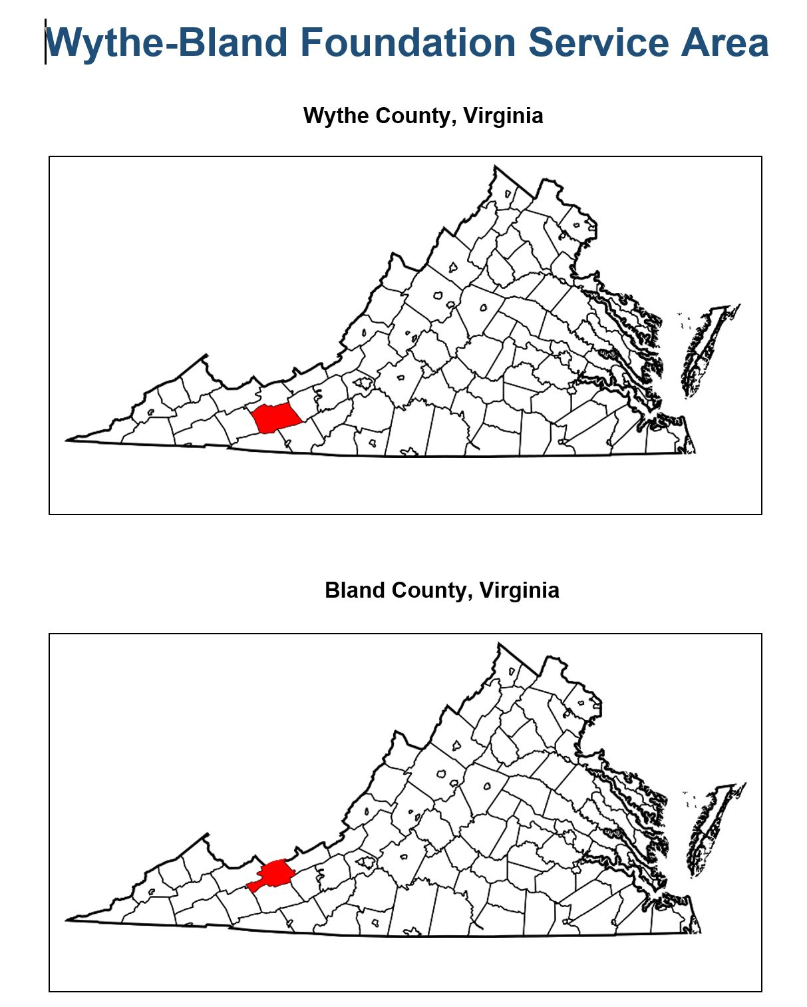

Key Stakeholder Survey Design

The Key Stakeholder Survey was designed with the primary aim of identifying the most pressing community issues. In addition to the identification of community issues, the survey was designed to discern why survey respondents believed the community issues they selected had the greatest effect on overall health and wellbeing of their community.

The survey was comprised of questions that led the participant to provide key answers that address needs within the service region. The survey was distributed via community meetings and nonprofit partners. The survey was completed by approximately 50 stakeholders, each representing unique backgrounds and organizations in Wythe and Bland Counties.

As mentioned above, the three major issues that noted in the survey results were substance abuse, mental health, and adverse childhood experiences (ACEs). The table below highlights some of the secondary data the three priority levels selected.

Table 1
Priority Focus Area | Sub-Measure
Substance Abuse | - Children with NAS  - Drug overdose deaths  - Opioid addiction  - Tobacco use
Mental Health | - Frequent mental distress  - Suicide rate
ACEs | - Child abuse/neglect  - Foster care

Through the identification of these priority areas, the Wythe-Bland Foundation, in coincidence with Wythe County Community Hospital and other community partners, can begin to implement programs and efforts to improve the health and well-being to those residing in Wythe and Bland Counties.

Population Profile

Population | Bland | Wythe
Population Estimates, July 1, 2021 | 6,173 | 28,178
Population Estimates, April 1, 2020 | 6,270 | 28,290
Population percent change – Apr.1, 2020 – Jul. 1, 2021 | -1.5% | -0.4%
Population Census, April 1, 2020 | 6,270 | 28,290
Population Census, April 1, 2010 | 6,824 | 29,235
Age and Sex
Persons under 5 years, percent | 3.5% | 4.8%
Persons under 18 years, percent | 14.6% | 19.5%
Persons 65 years and over, percent | 24.4% | 22.2%
Female persons, percent | 44.5% | 50.9%
Race and Hispanic Origin
White alone, percent | 94.1% | 94.6%
Black or African American alone, percent | 4.1% | 2.9%
American Indian and Alaska Native alone, percent | 0.2% | 0.2%
Asian alone, percent | 0.5% | 0.6%
Two or more races, percent | 1.1% | 1.6%
Hispanic or Latino, percent | 1.1% | 1.5%
Population Characteristics
Veterans, 2017-2021 | 371 | 1,880
Foreign born persons, percent, 2017-2021 | 0.1% | 1.0%
Housing
Housing Units, July 1, 2021 | 3,211 | 14,017
Owner-occupied housing unit rate, 2017-2021 | 83.4% | 76.8%
Median value of owner-occupied housing units, 2017-2021 | $118,600 | $132,400
Median selected monthly owner costs – with a mortgage, 2017-2021 | $1,052 | $1,093
Median selected monthly owner costs – without a mortgage, 2017-2021 | $341 | $317
Median gross rent, 2017-2021 | $702 | $637
Building permits, 2021 | 6 | 40
Families & Living Arrangements
Households, 2017-2021 | 2,260 | 12,125
Persons per household, 2017-2021 | 2.35 | 2.32
Language other than English spoken at home, percent of persons age 5+ | 2.3% | 1.8%
Computer and Internet Use
Households with a computer, percent, 2017-2021 | 2.3% | 1.8%
Households with a broadband Internet subscription, percent, 2017-2021 | 62.8% | 77.8%
Education
High school graduate or higher, percent of persons age 25+, 2017-2021 | 88.9% | 88.9%
Bachelor’s degree or higher, percent of persons age 25+ years, 2017-2021 | 13.3% | 19.6%
Health
With a disability, under age of 65 years, 2017-2021 | 10.4% | 14.4%
Persons without health insurance, under age of 65 years, 2017-2021 | 7.9% | 9.8%
Economy
Civilian labor force, total, percent of population age 16+ years, 2017-21 | 43.2% | 56.9%
Civilian labor force, female, percent of population age 16+ years, 2017-21 | 50.5% | 51.6%
Total health care and social assistance receipts/revenue, 2017 ($1,000) | 13,586 | 125,853
Total transportation and warehousing receipts/revenue, 2017 ($1,000) | 452 | 46,577
Total retail sale, 2017 ($1,000) | 25,969 | 699,947
Total retail sales per capita, 2017 ($1,000) | $4,083 | $24,277
Transportation
Mean travel time to work (minutes), workers ages 16+, 2017-2021 | 25.3 | 24.0
Income and Poverty | Bland | Wythe
Median household income (in 2021 dollars), 2017-2021 | $54,556 | $52,726
Per capita income in past 12 months (in 2021 dollars), 2017-2021 | $24,486 | $28,926
Persons in poverty, percent | 14.4% | 16.9%
Businesses
Total employer establishments, 2020 | 72 | 666
Total employment, 2020 | 1,308 | 9,533
Total annual payroll, 2020 ($1,000) | 87,874 | 349,716
Total employment, percent change, 2019-2020 | 5.0% | -4.5%
Total non-employer establishments, 2019 | 250 | 1,535
All employer firms, Reference year 2017 | 58 | 531
Geography
Population per square mile, 2020 | 17.5 | 61.2
Population per square mile, 2010 | 19.1 | 63.3
Land area in square miles, 2020 | 357.65 | 461.95
Land area in square miles, 2010 | 357.73 | 461.82
FIPS Code | 51021 | 51197
United States Census – QuickFacts

Health Rankings

 | Bland  (77/133) | Wythe  (86/133) | Virginia  (19/50) | United States
Health Outcomes
Premature Death | 9,200 | 9,800 | 6,700 | 7,300
Poor or Fair Health | 15% | 16% | 12% | 12%
Poor Physical Health Days | 3.4 | 3.5 | 2.7 | 3.0
Poor Mental Health Days | 4.7 | 5.0 | 4.1 | 4.4
Low Birthweight | 9% | 8% | 8% | 8%
Health Factors
Adult Smoking | 21% | 21% | 14% | 16%
Adult Obesity | 37% | 40% | 32% | 32%
Food Environment Index | 8.1 | 7.8 | 8.9 | 7.0
Physical Inactivity | 23% | 24% | 20% | 22%
Access to Exercise Opportunities | 90% | 73% | 83% | 84%
Alcohol-Impaired Driving Deaths | 0% | 23% | 30% | 27%
Sexually Transmitted Infections | 95.5 | 271.9 | 479.9 | 481.3
Teen Births | 15 | 30 | 15 | 19
Clinical Care
Uninsured | 8% | 10% | 9% | 10%
Primary Care Physicians |  | 2,390:1 | 1,350:1 | 1,310:1
Dentists | 2,060:1 | 2,820:1 | 1,350:1 | 1,380:1
Mental Health Providers | 1,540:1 | 430:1 | 450:1 | 340:1
Preventable Hospital Stays | 3,616 | 3,163 | 2,902 | 2,809
Mammography Screening | 33% | 32% | 39% | 37%
Flu Vaccines | 41% | 44% | 53% | 51%
Social & Economic Factors
High School Completion | 89% | 89% | 91% | 89%
Some college | 43% | 60% | 72% | 67%
Unemployment | 2.4% | 4.0% | 3.9% | 5.4%
Children in Poverty | 17% | 25% | 13% | 17%
Income Inequality | 3.8 | 4.2 | 4.8 | 4.9
Children in Single Parent Households | 18% | 22% | 24% | 25%
Social Associations | 9.6 | 9.1 | 11.0 | 9.1
Injury Deaths | 110 | 85 | 68 | 76
Physical Environment
Air Pollution – Particulate Matter | 6.8 | 6.9 | 7.3 | 7.4
Drinking Water Violations | 8% | 9% | 73% | 73%
Severe Housing Problems | 8% | 9% | 14% | 17%
Driving Alone to Work | 86% | 86% | 73% | 73%
Long Commute – Driving Alone | 35% | 29% | 41% | 37%
www.counthealthrankings.org

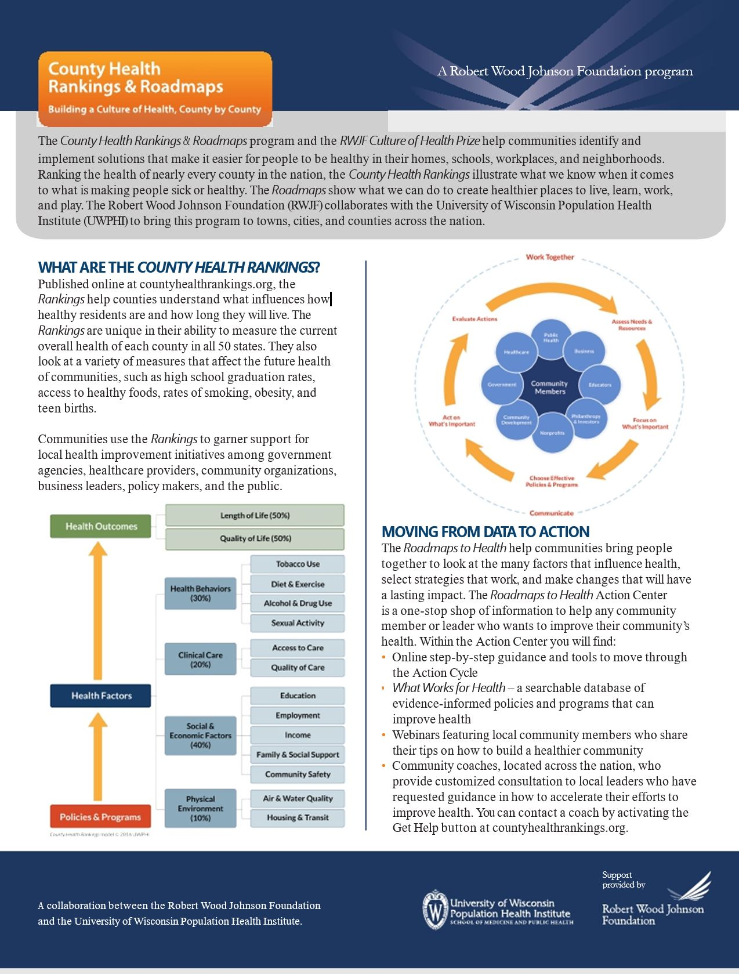

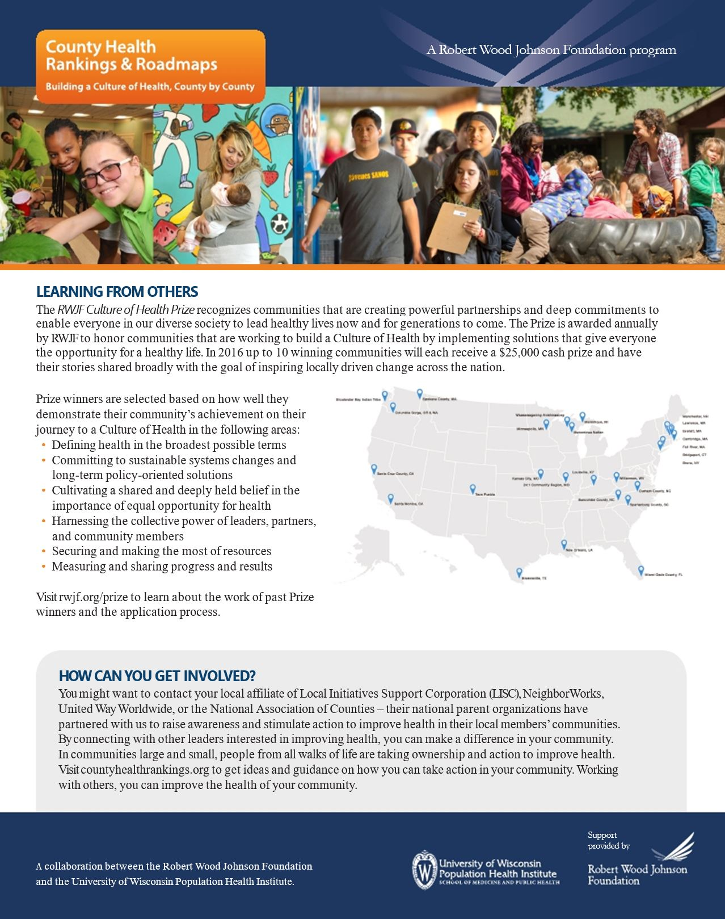

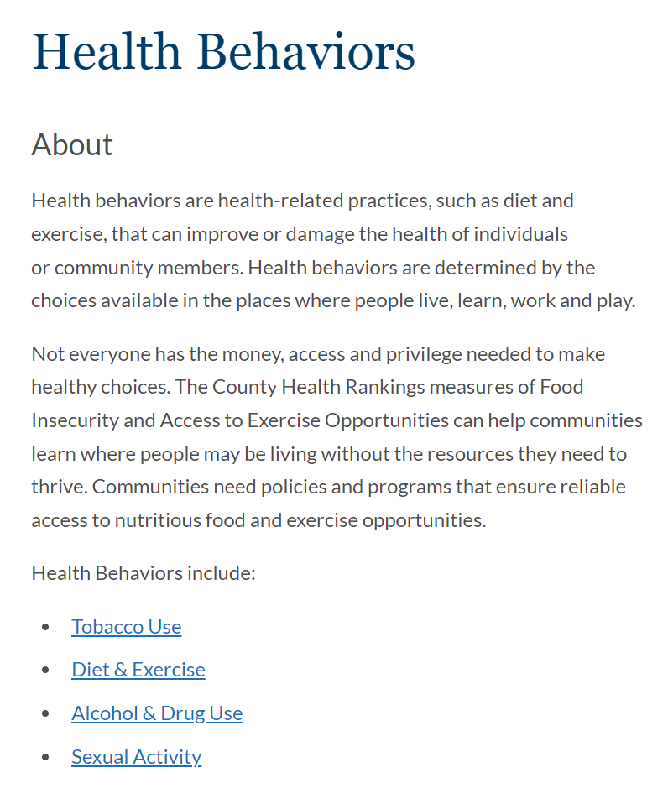

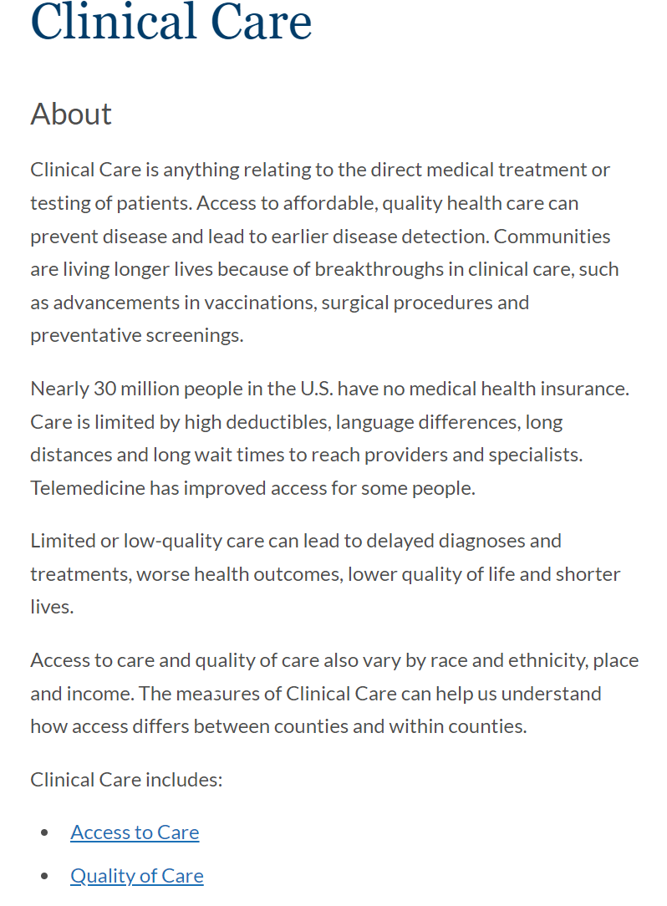

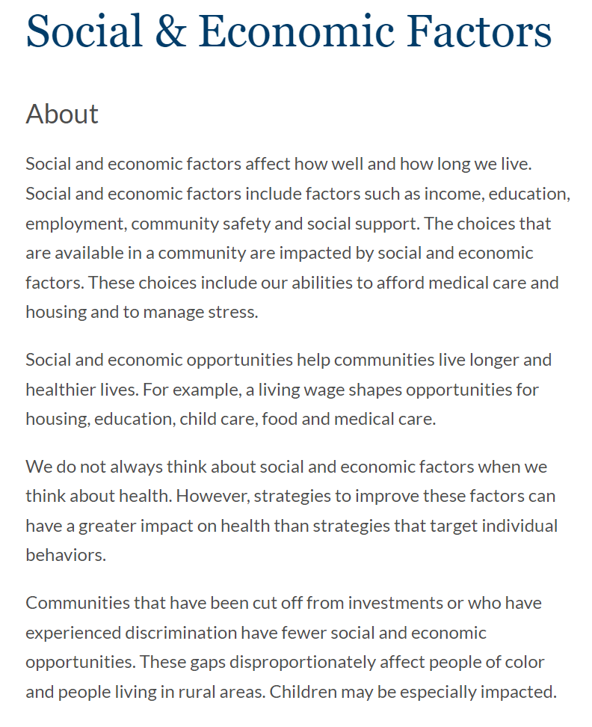
Social and Economic Factors Include:

- Education
- Employment
- Income
- Family & Social Support
- Community Safety

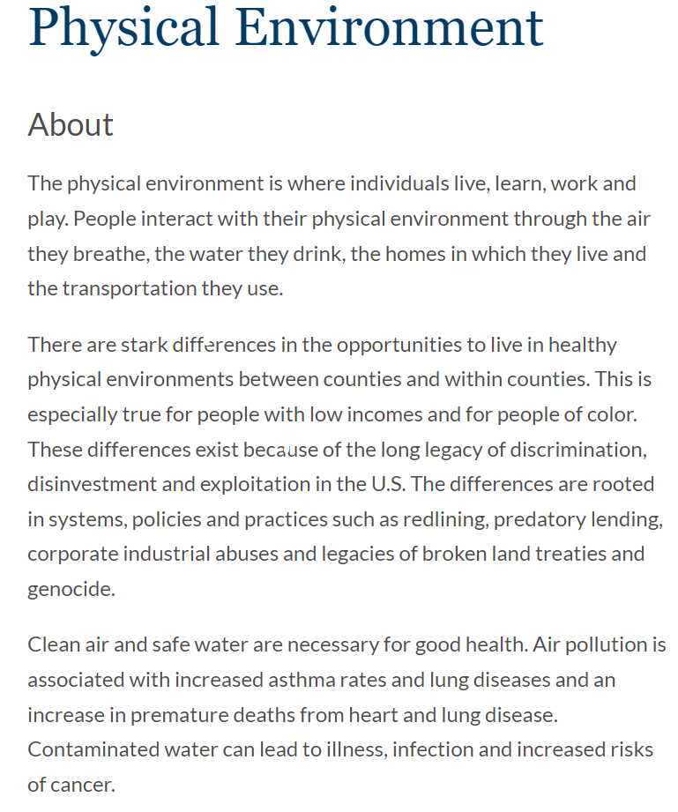

- Drug Use/Abuse (178)
- Mental Health (120)
- Cost of Healthcare (115)
- Child Abuse/Neglect (84)
- Obesity (81)
- Availability of Health Care (69)
- Unemployment (65)
- Alcohol Use/Abuse (63)
- Aging Issues (57)
- Cancer (55)
- Dental Care (49)
- Access to Healthy Foods (47)
- Lack of Exercise (45)
- Smoking/Tobacco Use (42)
- Diabetes (34)

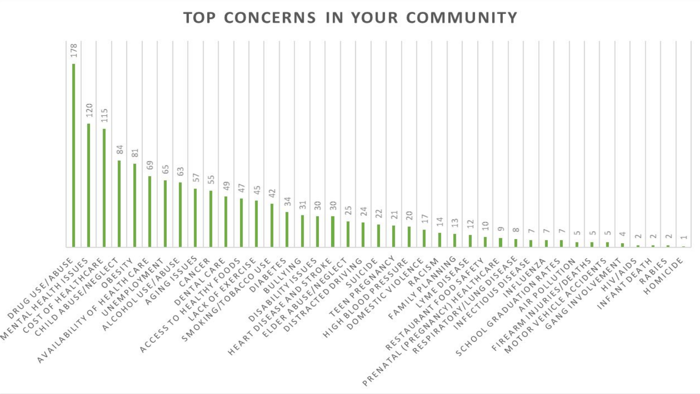
Virginia Department of Health, Wythe County Community Health Assessment (2019)

Results of Gaps and Assets Analysis

Drug Use/Abuse

Gaps:
- Knowledge of community available resources
- Limited insurance coverage
- Prison over prevention
- No Drug Court
- Early diagnosis of anxiety & depression
- Prescription drug abuse
- Availability/access to alcohol
- Transportation needs
- Access to mental Health providers

Assets:
- Police support
- Hospital Emergency Department
- Community Services Board
- Social Service organizations
- Support groups
- School programs

Mental Health

Gaps:
- Public Transportation
- Lack of knowledge of available resources
- 211 – Lack of understanding
- Privacy concerns
- Insurance coverage
- Lack of providers

Assets:
- Community Services Board
- Social Services
- Quasi-free health clinic
- Urgent care
- Hospital Emergency Department

Cost of Healthcare
Gaps:
- Lack of insurance
- Transitioning from Medicaid eligibility
- In-network healthcare providers
Assets:
- Quasi-free health clinic
- Nonprofit dental clinic
- Medical transportation program
- Emergency Medical Treatment and Labor Act (EMTALA)

Child Abuse/Neglect
Gaps:
- Adverse Childhood Experiences (ACEs)
- Neonatal Abuse Syndrome (NAS)
- Stable living environment
- Poverty
- Early diagnosis
- Lack of Social Service resources

Assets:
- Department of Social Service
- School system training
- 211
- Foster homes

Obesity
Gaps:
- Food insecurity for low income
- Healthy vending
- Expense associated with eating healthy
- Stress and sugar link
- Education (How to eat healthy)
- Access to physical activity
- Family support

Assets:
- School education
- WIC Voucher in Farmers Market
- Walking trails
- Nutrition classes
- Fit-for-Life program
- Community Clinic

Availability of Health Care
Gaps:
- Public Transportation
- Lack of knowledge of available resources
- 211-Lack of understanding
- Out of pocket costs – deductions
- Pride (Stigma associated with government assistance)
- Privacy concerns
- Insurance coverage
- Advocacy

Assets:
- Federal recognized Clinic
- Free Clinic
- Nonprofit transportation service
- Service and program information brochure
- Hospital (ER)
- Affordable Care Act or its replacement

Unemployment
Gaps:
- Sustainable living wages
- Lack of available workers
- Adult and child daycare availability
- Adequate adult training opportunities

Assets:
- Workforce development programs
- Virginia Employment Commission
- Community college scholarship programs
- Mentor trade programs

Alcohol Use/Abuse
Gaps:
- Knowledge of community available resources
- Limited insurance coverage
- Prison over prevention
- Early diagnosis of anxiety & depression
- Availability/access to alcohol
- Transportation needs
- Access to mental Health providers

Assets:
- Police support
- Hospital Emergency Department
- Community Services Board
- Social Service organizations
- Support groups
- School programs

Aging Issues
Gaps:
- Lack of transportation
- Adequate nutrition
- Food desert
- Socialization
- Knowledge of available resources
- Fixed income

Assets:
- Meals on Wheels
- Open Door Café
- The Ministerial Association
- Adult programs at Wellness Center
- Church programs

Cancer
Gaps:
- Lack of American Cancer Society Programs
- Transportation
- Local medical resources
- Support program
Assets:
- Limited medical transportation program
- Quasi-free medical clinic
- Community hospital facilities

Dental Care
Gaps:
- Public Transportation
- Lack of knowledge of available resources
- Lack of providers
- 211-Lack of understanding
- Out of pocket costs – deductions
- Pride (Stigma associated with government assistance)
- Privacy concerns
- Insurance coverage
- Advocacy

Assets:
- Federal recognized Clinic
- Free Clinic
- Limited medical transportation service
- Service and program information brochure
- School dental program

Access to Healthy Foods
Gaps:
- Food insecurity for low income
- Food desert
- Cost of food
- Lack of nutritional education

Assets:
- Open Door Café
- Packs Program
- Feeding Southwest Virginia
- Agape Food Pantry
- Austinville Pentecostal Holiness Church Food Pantry
- Meals on Wheels

Lack of Exercise
Gaps:
- Healthy vending
- Expense associated with eating healthy
- Stress and sugar link
- Education (How to eat healthy)
- Access to physical activity
- Family support

Assets:
- School education
- WIC Voucher in Farmers Market
- Walking trails
- Nutrition classes
- Fit-for-Life program
- Community Clinic
- Playgrounds

Smoking/Tobacco Use
Gaps:
- Education
- Addiction
- Vender adherence to state law

Assets:
- Smoking cessation classes
- Family support
- Health provider intervention
- No tobacco use policies

Diabetes
Gaps:
- Early detection
- Transportation to providers
- Lack of providers
- Poor diet
- Knowledge about available resources
- Access to physical activity

Assets:
- Community health clinics
- Medical providers
- Nonprofit food programs
- Farmers Market
- Walking tracks

CONCLUSION

As hospitals and health systems continue to work to make the communities within their primary service areas healthier, the identification of prioritized population health issues has become an area of strategic importance. Wythe-Bland Foundation is located in an area that population health is managed by the local governments of Wythe and Bland Counties, the Town of Rural Retreat, and the Town of Wytheville. In addition to government, the health systems of Ballad Health, Carilion Clinic, and Wythe County Community Hospital provide direct healthcare services.
Wythe and Bland Counties are located in a region with many health and social challenges that prioritization becomes even more important so that focused actions can be developed and implemented with strategic purpose. The allocation of hospital and health care resources to the prioritized issues, coupled with partnerships with other community organizations, will continue to build toward the goal of healthier region.

Key findings of the Community Health Survey include the need for more healthcare providers identified in the following fields of practice:
Family Care Health Providers
Dental
Behavioral Health
Substance Abuse

Additional focus is needed in the following fields of population health:
Child abuse
Nutrition
Aging
Exercise
Obesity
Economic growth
Tobacco use

